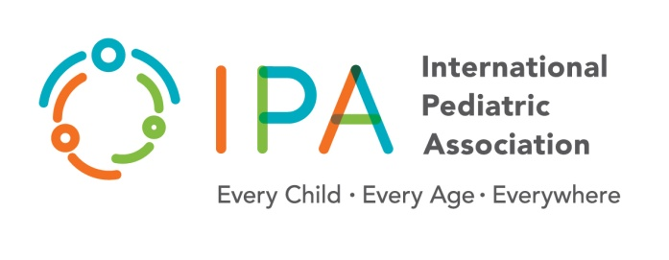

**International Pediatric Association (ipa)**

**Code of Conduct for the Election of IPA Standing COmmittee and Office bearers**

**A. The following actions are not allowed by contestants:**

1. Advertisements in lay press, any kind of press release and interviews about IPA election.
2. Placement of banners with personal names anywhere in the world.
3. Hosting of tea/lunch/dinner/cocktail parties for fellow members from IPA.
4. Negative propaganda about fellow contestants.
5. Use of pressure, inducement or coercion to get votes.
6. Impersonation of an eligible voter of IPA.

**B. Participation as faculty or delegate in programs of IPA/pharmaceutical companies/pediatric societies**

**B.1. Pharmaceuticals and equipment manufacturing companies:**

1. After the release of final list of contestants, the contestants will not participate as faculty (Speaker/Panelist/Moderator or Chairperson) in any academic program including webinar platforms hosted by any pharmaceutical company anywhere. Means stand alone or symposia in a congress
2. Contestants will not be permitted to avail any assistance from Pharmaceutical/equipment manufacturers for any activity connected with the election.
3. Contestants can be delegates at academic programs organized by Pharmaceutical Industry (with exception of Infant Milk Substitutes Industry), but must pay for their own travel, accommodation and registration.

**B.2. IPA programs:**

1. The contestants will not be faculty (speaker/panelists/moderator or chairperson) / organizing team members / coordinators of any IPA program after the release of the final list of contestants.
2. Contestants can be delegates at academic programs organized by IPA but must pay for their own travel, accommodation and registration does not concern SC members of the current tenure.
3. Slide shows, posters, distribution of pamphlets, etc. of contestants inside the venue of any IPA activity is strictly prohibited.

**B.3.Pediatric Societies activities:**

Contestants shall have the right to maintain their responsibilities and or activities within their mother regional societies.

**B.4.Sponsorship from Pharmaceutical or any Industry or Association or Person**

This is disallowed for contestants, for posting / personal distribution of electioneering material such as letters and pamphlets or travel or accommodation etc.

**C. Failure to disclose this may disqualify the candidate.**

**D. Breach of Code of Conduct; will be considered if:**

1. A written/email complaint is received about the conduct of a contestant from a member of IPA and confirmed by the Independent Election Committee (IEC) after investigation. Complaint will be considered only if complainant declares his/her name, & all relevant details (including email, mobile and telephone numbers) needed to identify him/her as a legitimate member of IPA.
2. A breach of code of conduct is observed by any of the IEC Members.
3. The breach is proved with ‘documentary' proof (audio/visual/print/electronic).
4. A documented breach of code of conduct by a contestant may be punishable by disqualification of his / her candidature by the IEC.
5. Any member who has any complaint related to the election shall give the same in writing or through his register email addressed to the IEC. Grievance should be submitted by individual and not by group of people. If there are more than one complainant, each complainant will separately deposit at the time of complaint.

**I understand that my signature on this document indicates that I have read and fully understand the prohibited activities and my professional ethical conduct responsibilities**

**Signature and date**

|  |  |  |
| --- | --- | --- |
|  | Date: |  |
| Participant Signature |  |  |