International Pediatric Association Pays Tribute
To
Prof. Fethi Bayoudh
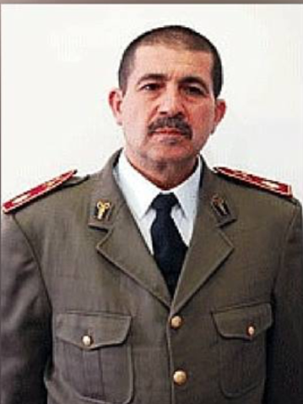
Late Prof. Fethi Bayoudh

International Pediatric Association would like to pay tribute to the life of one of its colleague Prof. Fethi Bayoudh, who passed away during the terrorist attack at Istanbul Airport on 28th June 2016 Tuesday night. Prof. Fethi was the head of the pediatric department of military hospital of Tunisian and one of the leading pediatricians in the Middle East.
During his mandatory military service, he rose to the rank of colonel-major and then took charge of the pediatrics department at the military hospital in Tunis, the capital. He also worked for several nongovernmental organizations that provided aid in war-torn countries.
IPA mourns for the loss of its colleague Prof. Fethi Bayoudh who was very generous and active and also remembers his valuable contribution towards the development of child health and society.
May the soul rest in peace and may the Almighty provide strength to his family members and to the close ones.

