TURKISH NATIONAL PAEDIATRIC SOCIETY TRAINING MEETING IN SANLIURFA AND SYRIAN REFUGEE CAMP VISIT IN OSMANIYE REGION

The central office of the Turkish National Pediatric Society along with its regional office in Sanlıurfa has organised a training meeting for paediatricians, family physicians and practitioners who provide healthcare service to the Syrian refugee children living in the camps around Sanlıurfa region. Seventy participants attended this meeting which was held on May 23rd, 2015. Sanlıurfa is a city located in the southeastern part of Turkey close to the Syrian border, where approximately 300 thousand Syrian refugees live. Children living in this region suffer from various health problems. In a training program tailored to help find solutions to these problems, faculty members from different universities participated to the meeting with lectures on topics including; feeding and nutrition in childhood, approach to the wheezing infant, approach to the child with metabolic disorder, approach to the child with chest pain, diagnostic approach to the child with rheumatological disease and when to suspect early puberty.
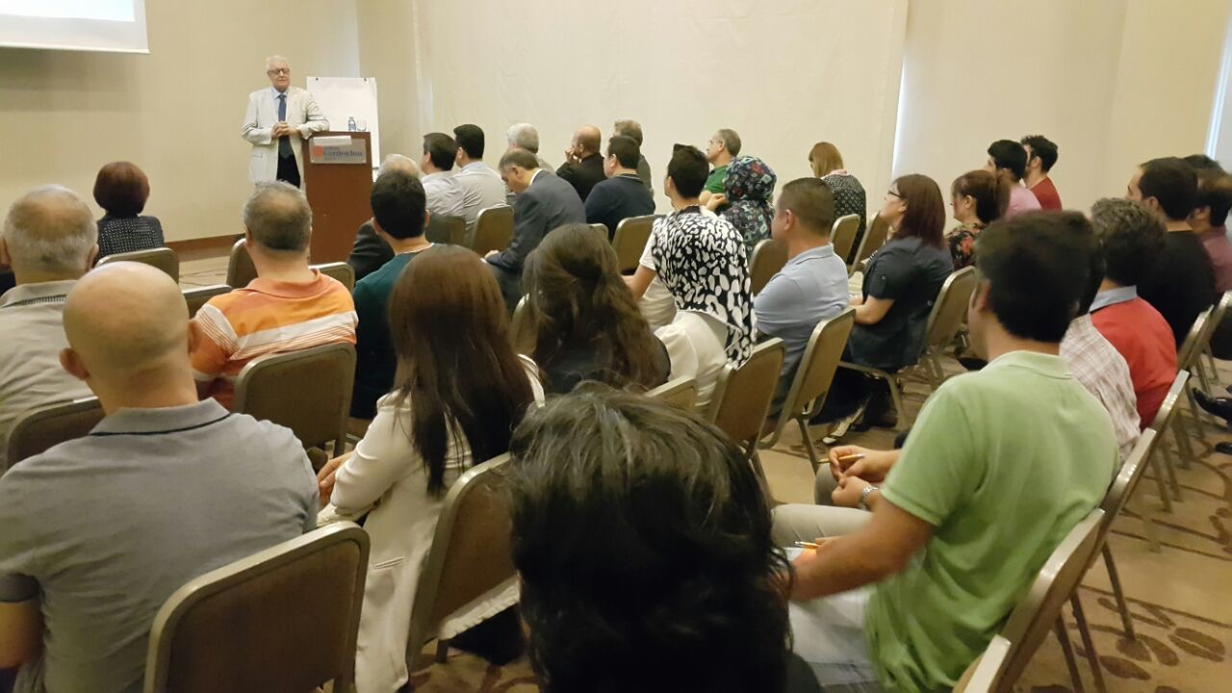

Executive Committee members of the Turkish National Pediatric Society with representatives of the Ministry of Health have visited a refugee camp in Osmaniye, a city located southern region of Turkey. The purpose of the visit was to observe the conditions the children living in, and to learn the opinion of healthcare providers and other managers of the camp about the things to do for a better service to the children.
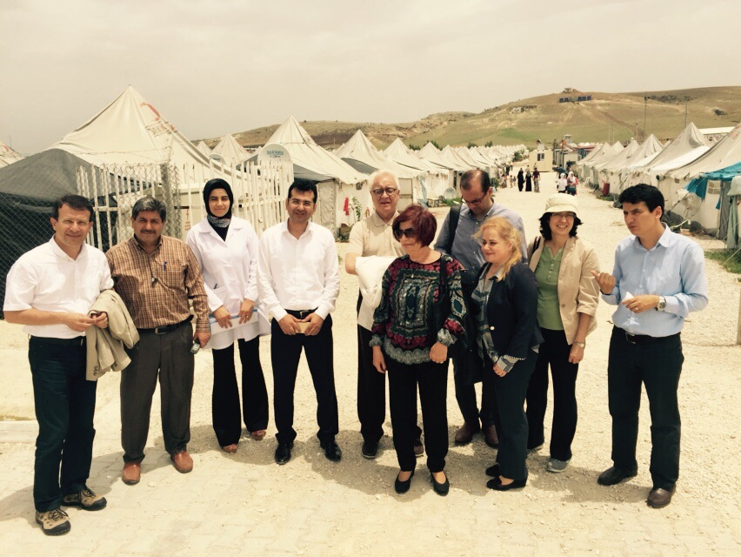
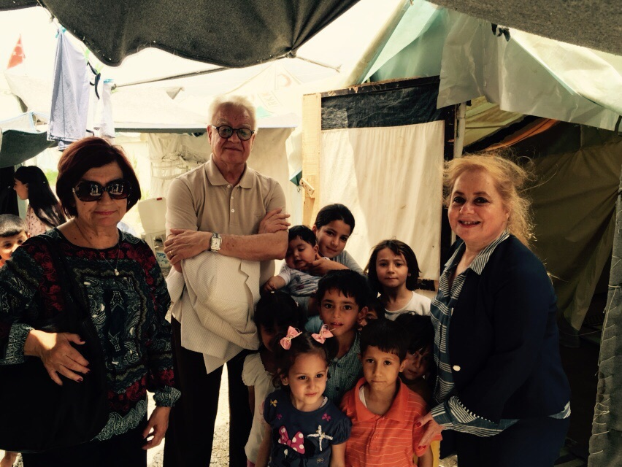
By then, June 2nd, 2015, the population of the camp was 9200 of which approximately one third were younger then 18. It was observed that Ministry of Health and Prime Ministry Disaster&Emergency Management Agency had made enormous efforts to provide support in all aspects of life for people living in the camp. However, a support seemed to be required especially in terms of mother education and communication, for access of the children to the services which were already provided and present in the camp. In collaboration with the Ministry of Health, the Turkish National Pediatric Society is now planning a training and education program especially for mothers consisting child feeding and nutrition, hygiene, prevention of infections, child development, how to use medications, family planning and how to access services in the camp.

